Hierarchical Clustering
In the previous sections, we looked at algorithms like K-Means and K-Prototypes. All of those methods share one strict rule: you must tell the computer exactly how many clusters (the number 'k') you want to find before the algorithm even looks at your data.
Hierarchical clustering is a clustering technique that builds a hierarchy of clusters instead of producing a single partition. Unlike K-Means, it does not require specifying the number of clusters (k) beforehand. Instead, it creates a full tree structure (dendrogram), allowing the user to choose the number of clusters after analyzing the data.
Key Idea:
Instead of finding one solution, hierarchical clustering generates all possible cluster groupings in a nested structure.
What is Hierarchical Clustering?
Hierarchical clustering is an algorithm that groups data points into a tree-like structure. It measures how similar data points are to each other and connects the most similar ones together, one step at a time, until every single piece of data is connected in one large group.
Analogy: Like organizing files into folders and subfolders based on similarity.
Hierarchical clustering does exactly this. It finds the most related items, groups them into small folders, and then groups those small folders into bigger folders.

The Dendrogram
The final result of hierarchical clustering is not just a list of groups. It outputs a specific type of tree diagram called a Dendrogram.
The dendrogram is the most valuable part of this method because it gives you a complete, visual history of how your data was grouped.
Here is how to read it:
- The Horizontal Axis (X-axis): This bottom line lists every individual data point in your dataset.
- The Vertical Axis (Y-axis): This line shows the distance (or difference) between the points or groups.
When two points are merged into a group, a horizontal line connects them to form a branch on the tree. The height of that horizontal line tells you exactly how far apart those two items were. If the horizontal line connecting them is very low, the items are nearly identical. If the horizontal line is very high up on the graph, the items are very different.
How to find 'k' using the Dendrogram:
To pick your final number of clusters, you simply draw a straight, horizontal line completely across the dendrogram. Count how many vertical branches your horizontal line cuts through. That number is your final cluster count (k).
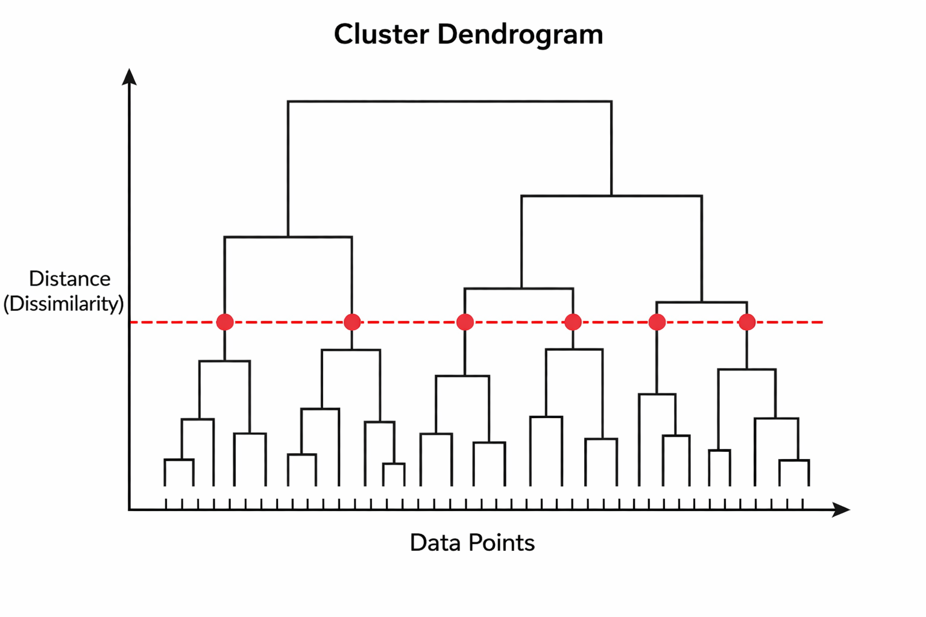
Important Insight :
Clusters should be formed by cutting the dendrogram at large vertical gaps, not arbitrarily. Larger gaps indicate stronger separation between clusters.
Key Limitation:
Different cut levels can produce very different clustering results, making interpretation subjective.

Types of Hierarchical Clustering
There are two completely opposite ways to build the cluster tree.
1. Agglomerative (Bottom-Up)
This is the standard method. When people say "hierarchical clustering," they almost always mean this one.
- Start: Every single data point starts entirely alone as its own separate cluster. If you have 100 rows of data, you start with 100 clusters.
- Action: The algorithm finds the two clusters that are closest together and merges them into a single new cluster.
- Repeat: It repeats this merging step over and over. The groups get larger and larger until all data points are merged into one giant, final cluster.

Linkage Methods: Measuring Distance Between Groups
When every data point is alone, calculating distance is simple. You just measure the space between point A and point B.
But once the algorithm starts merging points into groups, a new problem appears: How do you calculate the distance between a group of 5 points and a group of 10 points?
To solve this, we use a rule called a Linkage Method. You must select one of these rules before running the code.
1. Single Linkage (Nearest Neighbor)
- How it works: It looks at Group A and Group B. It finds the single point in A and the single point in B that are closest to each other. It uses the distance between those two specific edge points as the distance for the whole group.
- Result: It tends to create long, thin, chain-like clusters. It reacts very poorly to outliers.
2. Complete Linkage (Furthest Neighbor)
- How it works: It finds the point in Group A and the point in Group B that are the furthest away from each other. It uses that maximum distance as the distance for the whole group.
- Result: It forces clusters to be very tight and compact. It handles outliers much better than Single Linkage.
3. Average Linkage
- How it works: It calculates the distance between every single point in Group A to every single point in Group B. Then, it calculates the mathematical average of all those distances.
- Result: It offers a safe, balanced compromise between Single and Complete linkage.
4. Ward’s Method (Minimum Variance)
- How it works: It does not measure the direct distance between points. Instead, it measures variance (how spread out the data is). It looks at all possible merges and always chooses to merge the two groups that cause the smallest increase in total variance.
- Result: This is the most popular default method in data science. It consistently creates very neat, round, and evenly sized clusters.
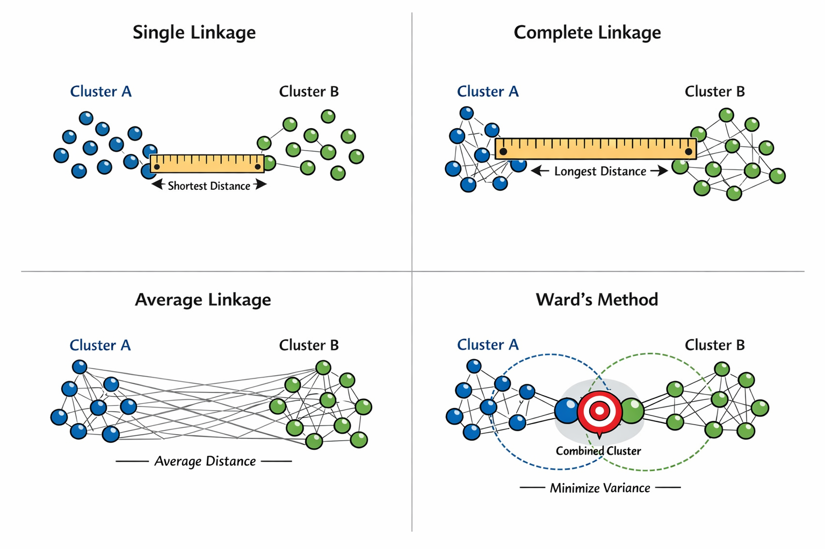
Before any linkage can happen, the algorithm needs to know the baseline distance between the individual data points.

Formula 1: Euclidean Distance
This is the standard formula used to find the straight-line distance between two single data points (Point p and Point q).

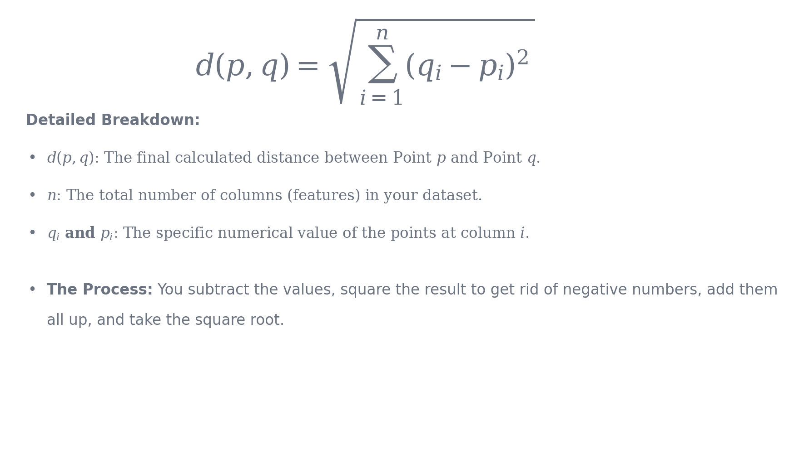

Formula 2: Ward's Minimum Variance Criterion
If you choose Ward's Method as your linkage rule, the algorithm uses this formula to decide which two clusters (Cluster A and Cluster B) to merge next.
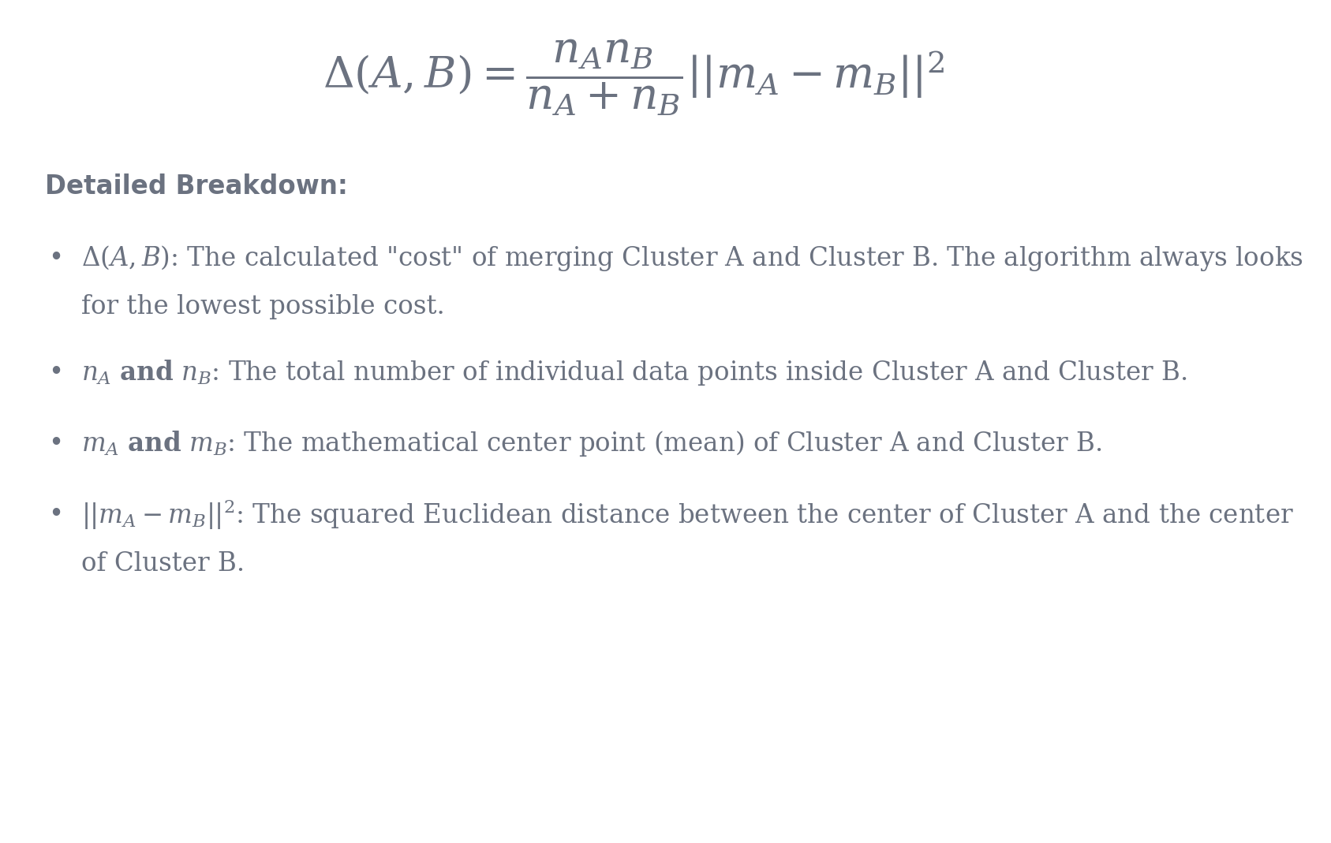

Implementation of Agglomerative Clustering

Step-by-Step Algorithm
Algorithm Steps:
- Initialize each point as a separate cluster
- Compute distance matrix
- Merge closest clusters based on linkage
- Update distance matrix
- Repeat until one cluster remains
Key Property:
This is a greedy algorithm once a merge happens, it cannot be reversed.

Algorithm Flow Map

Python Implementation
<python>
import numpy as np
import matplotlib.pyplot as plt
from scipy.cluster.hierarchy import dendrogram, linkage
from sklearn.cluster import AgglomerativeClustering
# 1. Create a simple dataset (10 points, 2 features)
X = np.array([[5, 3], [10, 15], [15, 12], [24, 10], [30, 30],
[85, 70], [71, 80], [60, 78], [70, 55], [80, 91]])
# 2. Build the Linkage Matrix
# We use 'ward' linkage and standard 'euclidean' distance
Z = linkage(X, method='ward', metric='euclidean')
# 3. Plot the Dendrogram to visually check the history
plt.figure(figsize=(10, 5))
plt.title('Hierarchical Clustering Dendrogram')
plt.xlabel('Data Point Index')
plt.ylabel('Distance (Ward)')
dendrogram(Z)
plt.show()
# 4. Train the final model
# After looking at the dendrogram, we choose to cut it at 2 clusters.
model = AgglomerativeClustering(n_clusters=2, metric='euclidean', linkage='ward')
cluster_labels = model.fit_predict(X)
print("Final Cluster Assignments for the 10 points:")
print(cluster_labels)
<python>
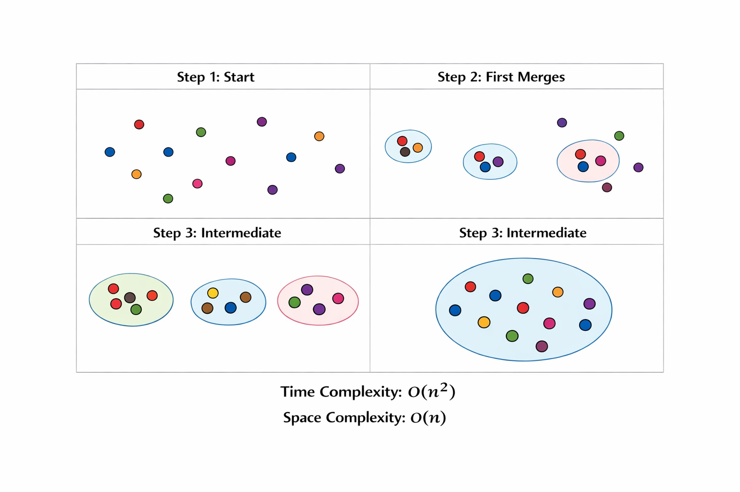

Limitations
- High Time Complexity: O(n³) due to repeated merging and distance updates
- High Space Complexity: O(n²) due to distance matrix storage
- Greedy Nature: Early incorrect merges cannot be corrected
- Sensitive to Noise: Outliers can distort cluster structure
Failure Case:
Hierarchical clustering performs poorly when clusters are not well-separated or contain significant noise.

Where is this mostly used?
- Biology and Genomics: Scientists use it heavily to group genes with similar expression patterns or to build taxonomy trees that show how different animal species share common DNA.
- Document Categorization: Grouping a large archive of text files into a folder structure. It starts with specific documents at the bottom and merges them into broader categories at the top.
- Customer Segmentation (Small Scale): Grouping high-value clients where business analysts need to see the exact relationship tiers between individual buyers.
Note :Use Hierarchical Clustering when you have a small dataset (usually under 5,000 rows) and your primary goal is to visually explore the relationships and structure of the data without guessing the number of clusters beforehand.
COMPARISON WITH K MEANS:

Concept | K-Means | Agglomerative | Divisive
Start | Random centroids | Each point separate | One big cluster
Process | Reassign + update | Merge closest | Split largest
Structure | Flat | Bottom-up tree | Top-down tree
Output | One solution | Full hierarchy | Full hierarchy
Decision Type | Iterative optimization | Greedy merge | Recursive split

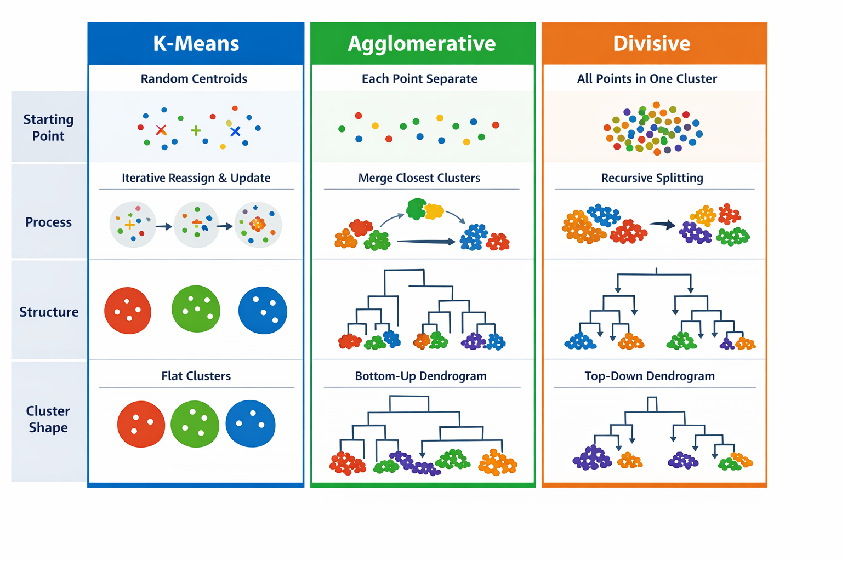

Divisive Clustering (Top-Down)
Divisive clustering starts with all data in one cluster and recursively splits it.
It is computationally expensive because finding the optimal split is complex, so K-Means (k=2) is often used as an approximation.
Key Limitation:
If the initial split is incorrect, all subsequent clustering is affected.
.

The Math: How to Split (DIANA Approach)
To split a cluster, the algorithm looks for the point that is the most "dissimilar" to the rest of its group.
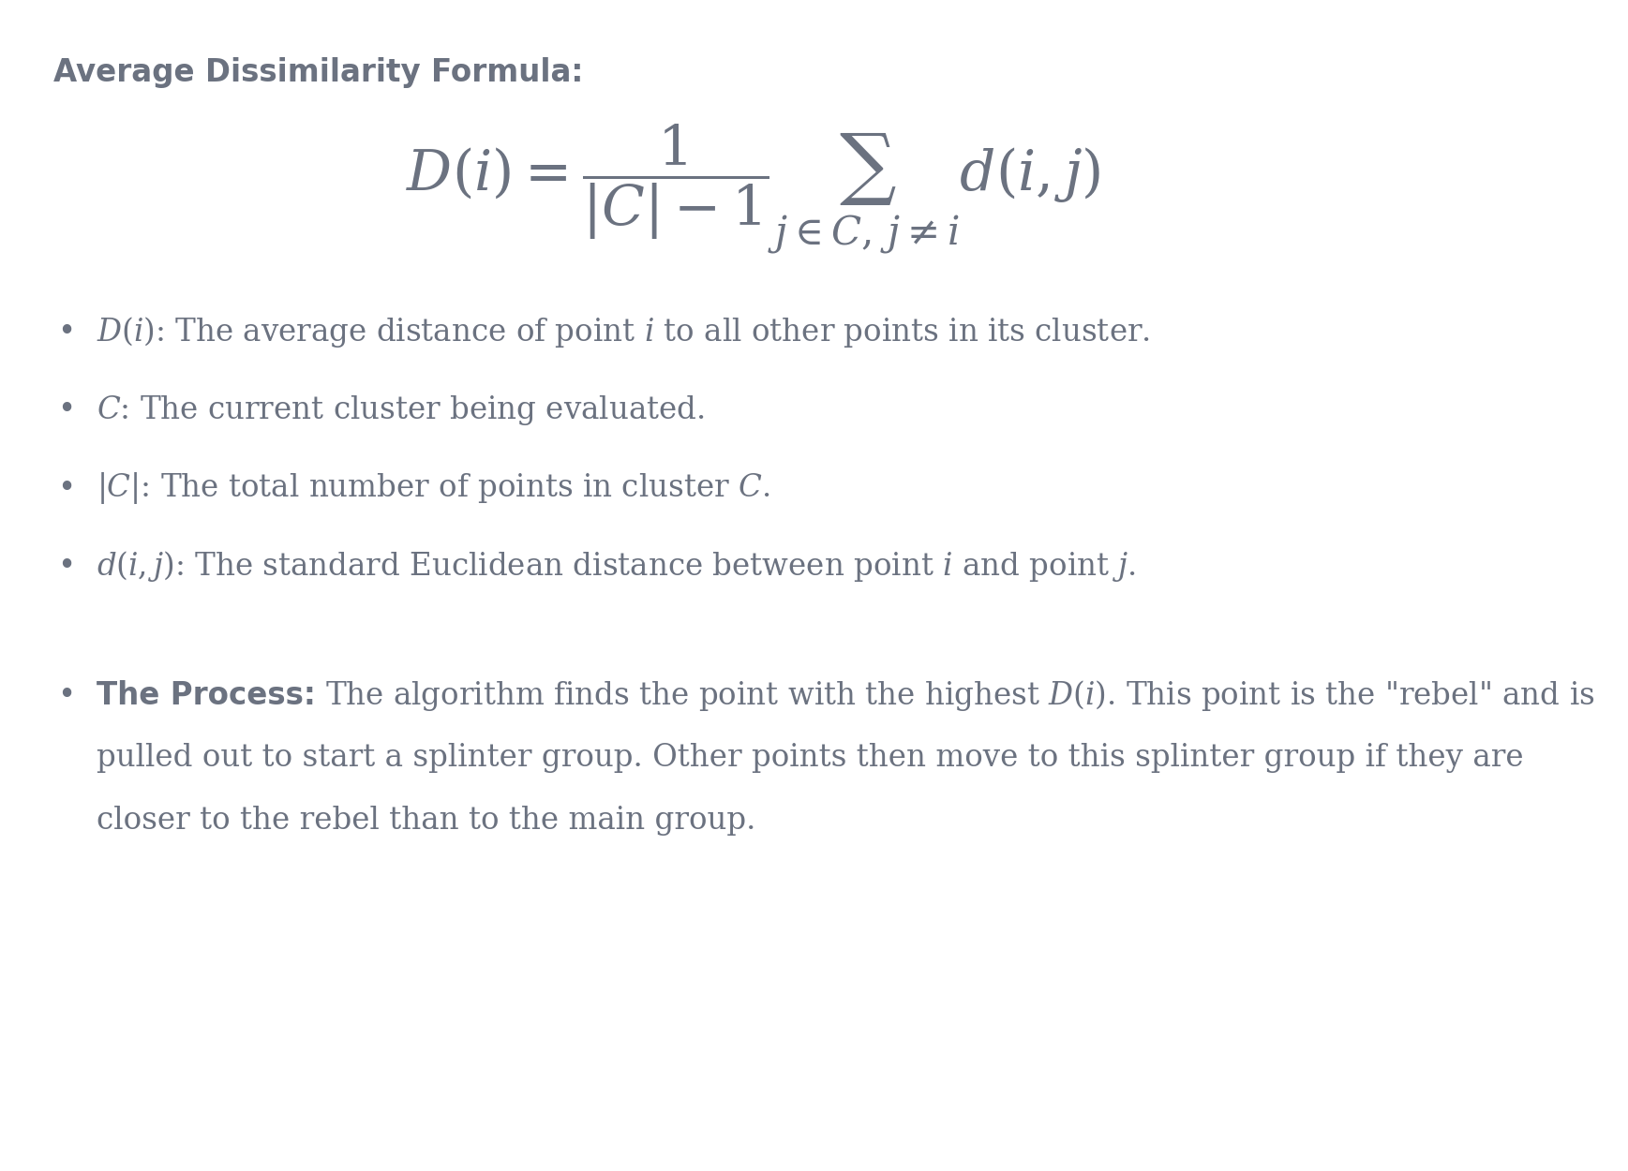

Step-by-Step Algorithm & Visual Prompts
Step 1: Initialize
Place every single data point into one massive, single cluster.
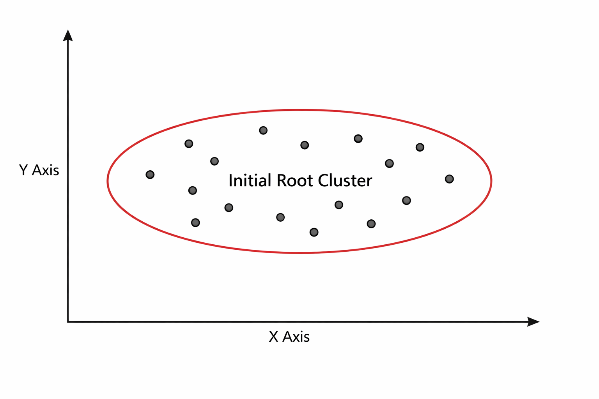
Step 2: Identify the Worst Cluster
Look at all current clusters. Find the cluster that has the highest variance (the one where the points are the most spread out). In the first step, there is only one cluster, so it is chosen automatically.
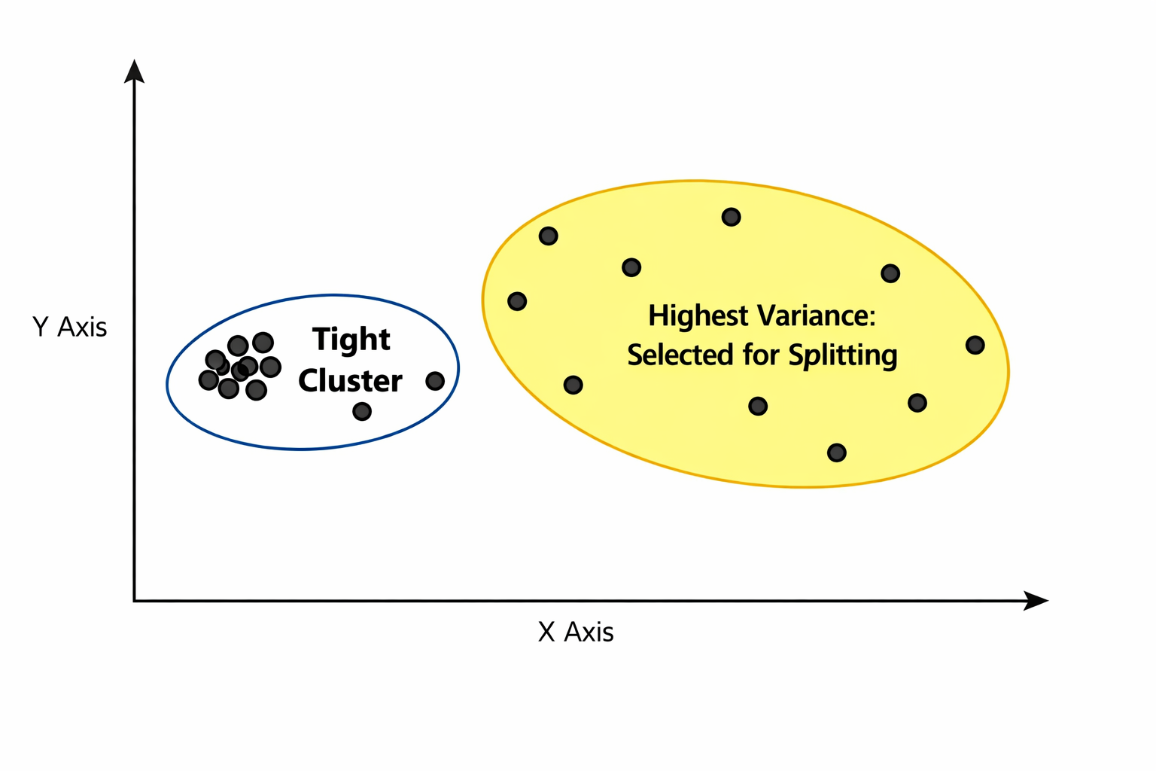
Step 3: Split the Cluster
Split the chosen cluster into two smaller, tighter clusters. This is usually done by running K-Means with k=2 just on the points inside that specific group.
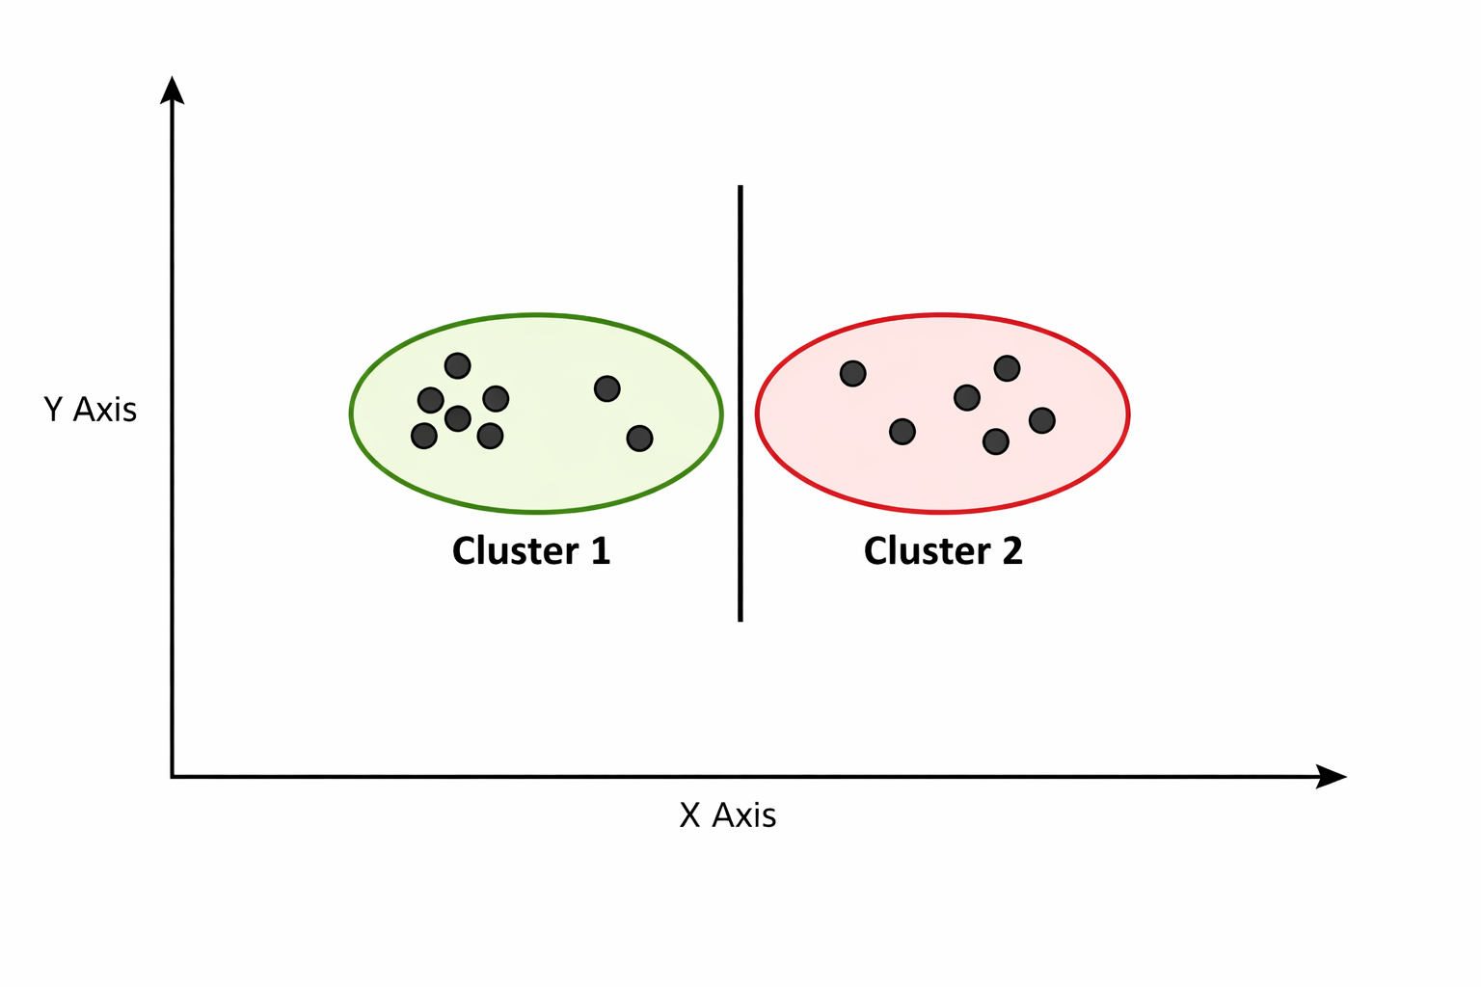
Step 4: Update and Repeat
Record the split on the dendrogram (drawing the branches downward). Repeat Steps 2 and 3. Keep finding the most spread-out group and cutting it in half until every single data point is alone in its own cluster.
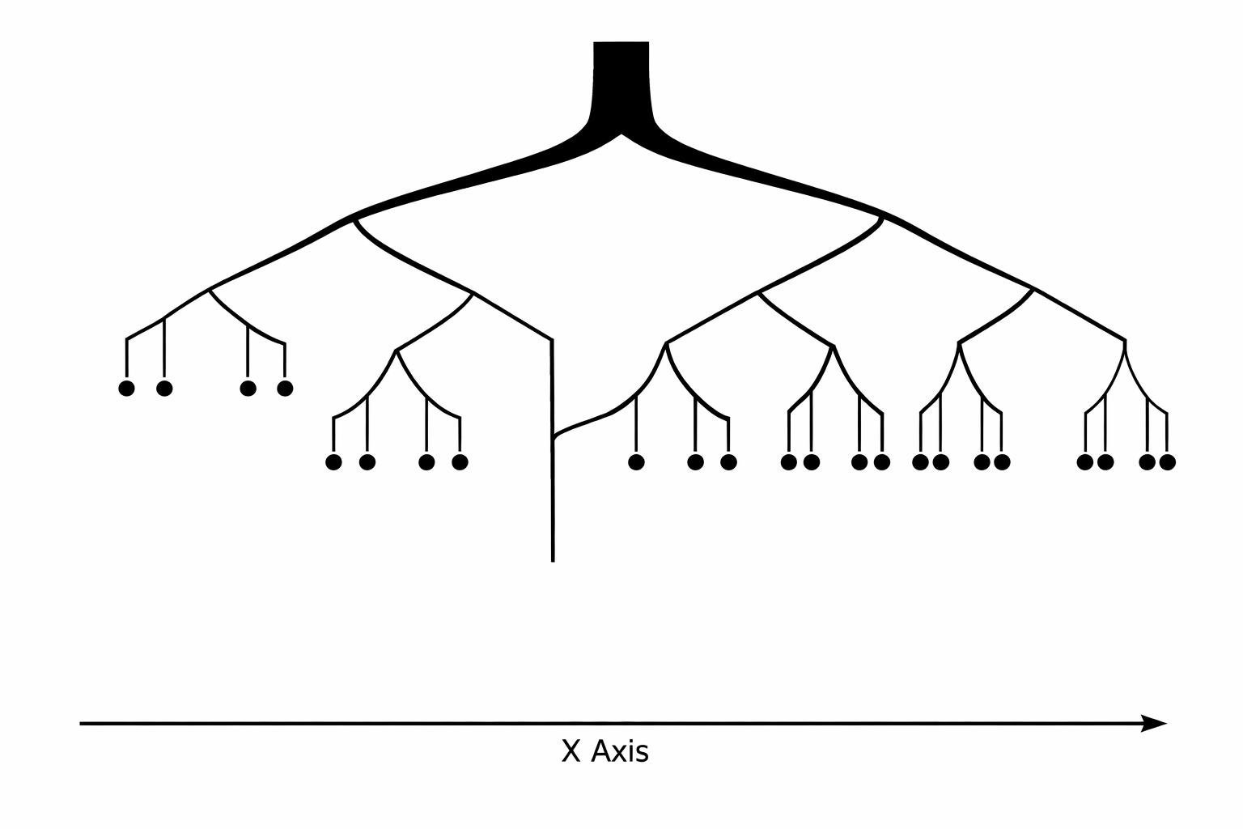

Divisive Flow Map
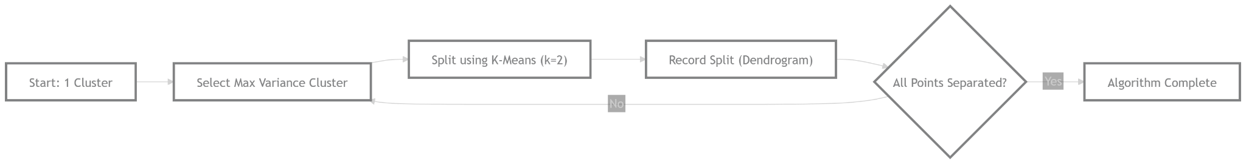

Python Implementation (Divisive)
<python>
Python
from sklearn.cluster import KMeans
import numpy as np

# Sample Data
X = np.array([[1, 2], [1, 4], [1, 0], [10, 2], [10, 4], [10, 0]])

def divisive_clustering(data, current_clusters):
# Stop when every point is its own cluster
if len(current_clusters) == len(data):
return current_clusters

# Find the cluster with the most points to split next
largest_cluster_idx = max(range(len(current_clusters)), key=lambda i: len(current_clusters[i]))
cluster_to_split = current_clusters.pop(largest_cluster_idx)

# If the cluster only has 1 point, we can't split it
if len(cluster_to_split) == 1:
current_clusters.append(cluster_to_split)
return current_clusters

# Use K-Means (k=2) to cut the cluster in half
kmeans = KMeans(n_clusters=2, n_init=10, random_state=42)
labels = kmeans.fit_predict(cluster_to_split)

# Create the two new splinter groups
group1 = cluster_to_split[labels == 0]
group2 = cluster_to_split[labels == 1]

current_clusters.append(group1)
current_clusters.append(group2)

print(f"Split into: \nGroup A: {group1}\nGroup B: {group2}\n---")

# Repeat the process recursively
return divisive_clustering(data, current_clusters)

# Start the process with all data in one cluster
initial_group = [X]
print("Starting Divisive Clustering...")
final_groups = divisive_clustering(X, initial_group)
<python>

Limitations of Divisive Clustering
- Extreme Computational Cost: Finding the absolute mathematical best way to split a large group of data into two takes a massive amount of computer power. Specifically, for a cluster of n points, there are 2^{(n - 1 )} - 1 possible ways to split it. Unless you use a shortcut like K-Means to force the split, it is too slow for real-world use.
- Once Split, Never Fixed: Just like Agglomerative clustering, Divisive has no "undo" button. If it makes a poor split at the very top of the tree, that mistake permanently affects all the branches below it.

Where is Divisive mostly used?
Because of its speed issues, Divisive clustering is rare. However, it is used in highly specific scenarios where the "big picture" matters more than the small details:
- Information Retrieval: When querying a massive database, it is faster to split the database into large, broad topics from the top down to quickly eliminate irrelevant sections, rather than building up from individual files.
Use Agglomerative Clustering for almost all standard data science tasks where you need a visual dendrogram, but switch to Divisive Clustering only if your primary goal is to identify a few large, broad groups at the top of the tree rather than caring about how individual points relate at the bottom.

When to Use Hierarchical Clustering:
- Small datasets (<5000 points)
- When number of clusters is unknown
- When interpretability and visualization are important
When NOT to Use:
- Large datasets
- High-noise data
- Real-time applications
QUIZ

- Why is hierarchical clustering preferred when working with unknown datasets?
a) It is faster than K-Means
b) It does not require specifying k beforehand
c) It handles noise better than all algorithms
d) It reduces dimensionality automatically
- In a dendrogram, what indicates that two clusters are very similar?
a) A long vertical line
b) A low horizontal merge height
c) A large number of branches
d) A steep slope
- Which type of clustering starts with each point as its own cluster?
a) Divisive
b) Agglomerative
c) Density-based
d) Partition-based
- Why does single linkage produce chain-like clusters?
a) It maximizes intra-cluster variance
b) It considers only the closest pair of points
c) It averages all distances
d) It ignores outliers
- Why is hierarchical clustering considered a greedy algorithm?
a) It randomly selects clusters
b) It always picks global optimum
c) It makes locally optimal merges without revisiting
d) It minimizes distance globally
- Why is Ward’s method often compared to K-Means?
a) Both use centroids directly
b) Both minimize within-cluster variance
c) Both are density-based
d) Both avoid distance calculations
- You observe a dendrogram with no large vertical gaps. What does this imply?
a) Perfect cluster separation
b) No meaningful clusters exist
c) Too many clusters exist
d) Algorithm failed
- Which scenario will MOST likely break hierarchical clustering?
a) Small dataset
b) Well-separated clusters
c) Early incorrect merge due to noise
d) Low dimensional data
- Why is hierarchical clustering not scalable?
a) It uses recursion
b) It requires repeated distance matrix updates
c) It uses centroids
d) It requires labeled data
- Why is divisive clustering rarely used in practice?
a) It cannot form clusters
b) It is less accurate than agglomerative
c) Optimal splitting is computationally infeasible
d) It does not use distance metrics

ANSWERS:
- b
- b
- b
- b
- c
- b
- b
- c
- b
- c

